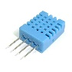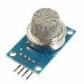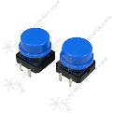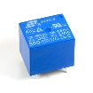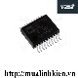

MASTER

STM32F407VGT6

SLAVE BUTTON

PIC16F628A

SLAVE DEVICE

PIC16F628A

SLAVE SENSOR

PIC16F628A

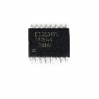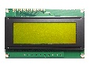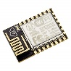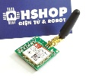

SLAVE SPECIAL

PIC16F887

SIM800A

DS3231

LCD 20x4

ESP8266

ADE7753

RS485

Internet

Internet

A

MASTER

SLAVE 01

SLAVE 02

SLAVE 04

SLAVE 05

B